WEEK 2
START MENU TO START THE GAME
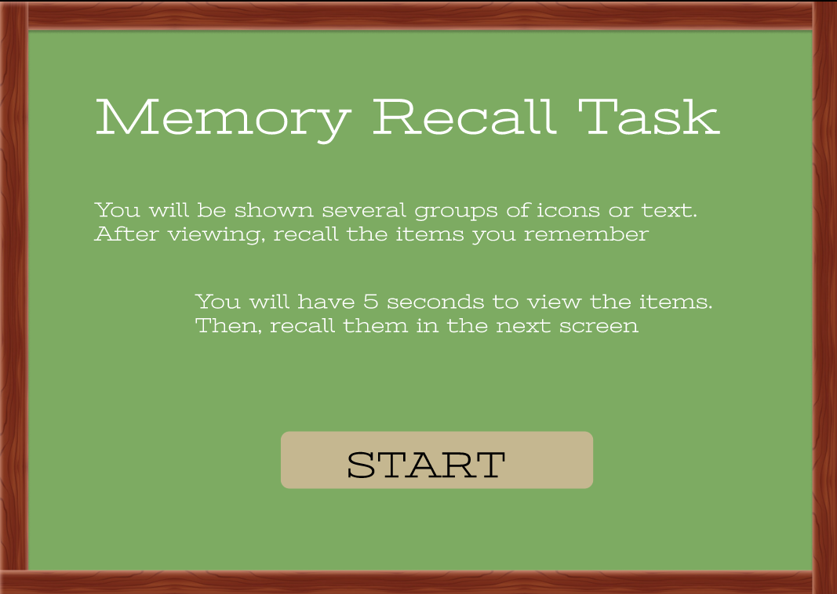

GAME START WITH TIMER
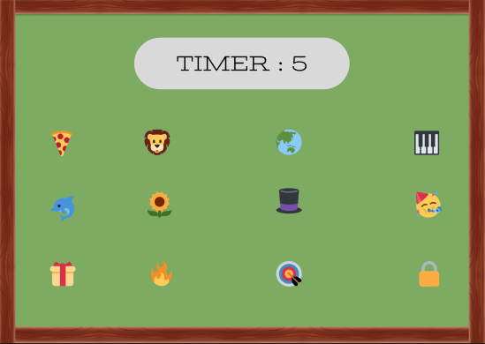

TO RECALL THE MEMORY ITEMS
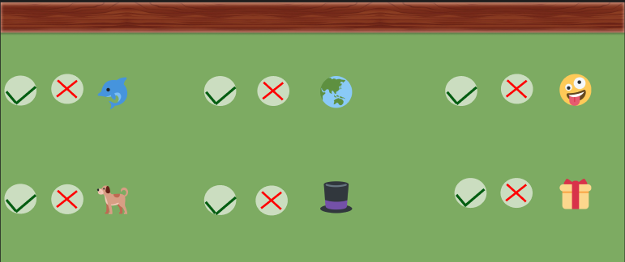

SCORE WILL BE A DISPLAYED
